Comandos PSQL(PostgreSQL)

# Diagrama Entidade-Relacionamento

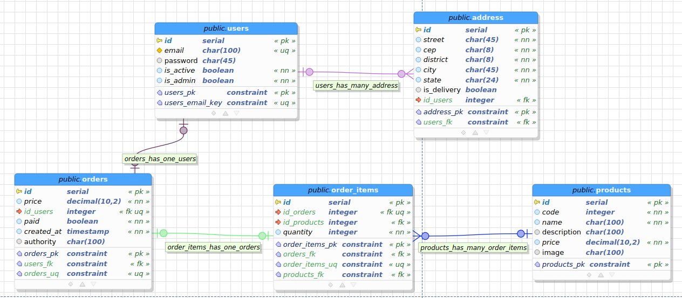

# 1.Criação banco de dados e tabelas:

create database luizacode;

create table users(

id serial,

email char(100),

password char(45),

is_active boolean default true,

is_admin boolean default false,

is_admin bool null default false,

constraint email_uq unique (email),

constraint users_pkey primary key (id)

);

create table address(

id serial,

user_id int,

street char(45),

cep char(8),

district char(45),

city char(45),

state char(24),

is_delivery boolean default true,

constraint address_pkey primary key(id),

constraint fk_user foreign key(id) references users(id)

);

drop table orders cascade;

create table orders(

id serial not null,

user_id int,

address_id int,

price decimal(10,2),

paid boolean default false,

created_at timestamp not null default now(),

authority char(100),

constraint orders_pkey primary key(id),

constraint order_uq unique(id),

constraint fk_user FOREIGN KEY(user_id) references users(id),

constraint fk_address FOREIGN KEY(address_id) references address(id)

);

drop table order_items;

create table order_items(

code char(100) generated always as (CAST(id_order as char) || '_' || CAST(id_product as char)) stored,

id_order int,

id_product int,

quantity integer not null default 1,

constraint fk_order foreign key(id_order) references orders(id),

constraint fk_product foreign key(id_product) references products(id),

constraint order_product_uq unique(id_order, id_product),

constraint order_product primary key(code)

);

create table products(

id serial primary key,

code integer not null,

name char(100) not null,

description char(100),

price decimal(10,2) not null,

image char(100)

);

# 2.Criação de user e permissão

/* DCL - Gerenciamento de acessos e permissões */

create user karlapereira with password 'luizacode123';

grant all privileges on database luizacode to karlapereira;

SELECT * FROM pg_catalog.pg_user;

# 3.Inserção de dados nas tabelas

/* DCL - Add/Modify data */

insert into users (email, password)

values ('karlapereira', 123);

select * from users;

insert into address (user_id, street, cep, district, city, state)

values (1, 'rua xxxxxx, xx', '01311100', 'xxxx', 'sao paulo', 'sp');

insert into address (user_id, street, cep, district, city, state)

values (1, 'rua xxxxxx, xx', 'xxxxxxxx', 'xxxx', 'belo horizonte', 'mg');

select * from address;

insert into products (code, name, description, price, image)

values (1000, 'notebook', 'Acer Nitro 5 - core I7 - geforce GTX', 5500.00, 'notebook1.jpeg');

insert into products (code, name, description, price, image)

values (2000, 'Iphone', 'Apple', 8500.00, 'iphone.jpeg'),

(3000, 'Monitor', 'Samsung', 2500.00, 'monitor.jpeg');

update products set price = 5500.89 where code=1000;

select * from products;

insert into orders(user_id, address_id, price, paid)

values (1, 1, 5500.00, true);

select * from orders;

insert into order_items (id_order, id_product, quantity)

values (1, 1, 2),

(1,2,1),

(1,3,5);

select * from order_items oi;

# 4. JOIN

select

u.id,

u.email,

a.city,

a.state,

o.price,

o.paid,

oi.id_product,

oi.quantity,

p.name

from users u

inner join address a on a.user_id = u.id

inner join orders o on o.user_id = u.id and o.address_id = a.id

inner join order_items oi on oi.id_order = o.id

inner join products p on p.id = oi.id_product ;

# 5. Agregação

/* Agregação */

select

count(*), price

from products p

group by p.price;

select

min(code)

from products p;

select distinct

p.price

from products p ;